# Practice of Arrays in C++

# Take 10 numbers as input and print them

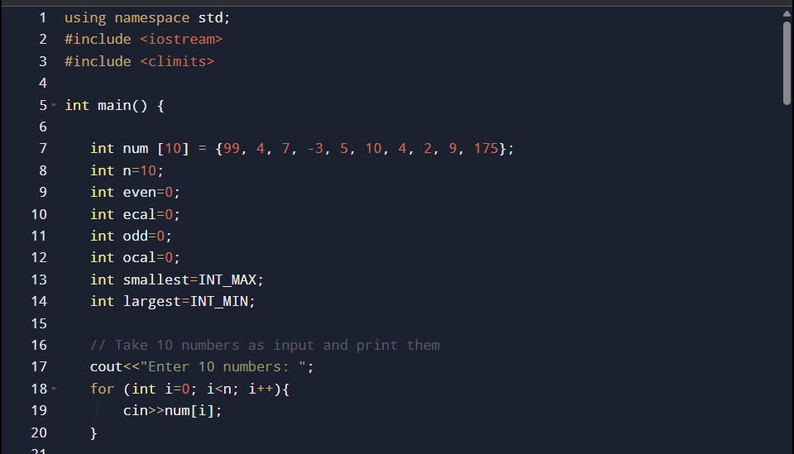

# Count even and odd numbers in the array

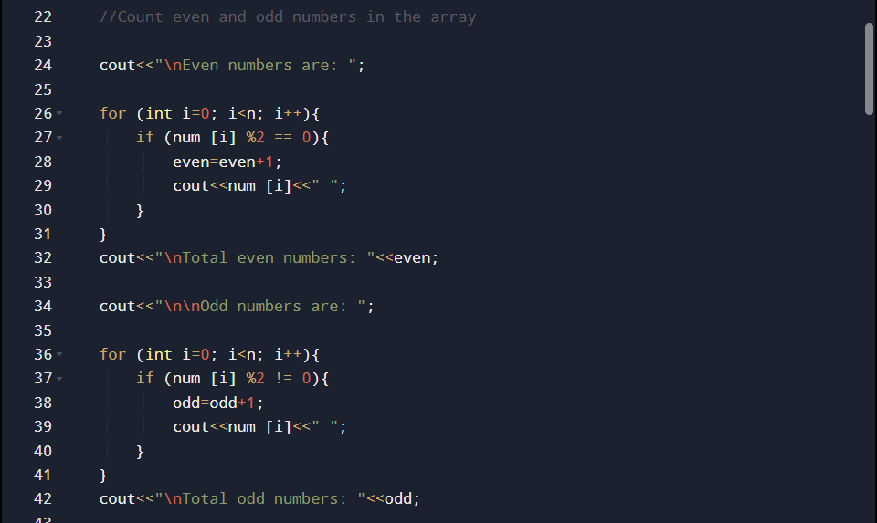

# Find the **largest** and **smallest** number

# Count how many numbers are divisible by 5

# Reverse the array elements

# Print only positive numbers

# Calculate the sum of array elements

# Find how many times a specific number appears

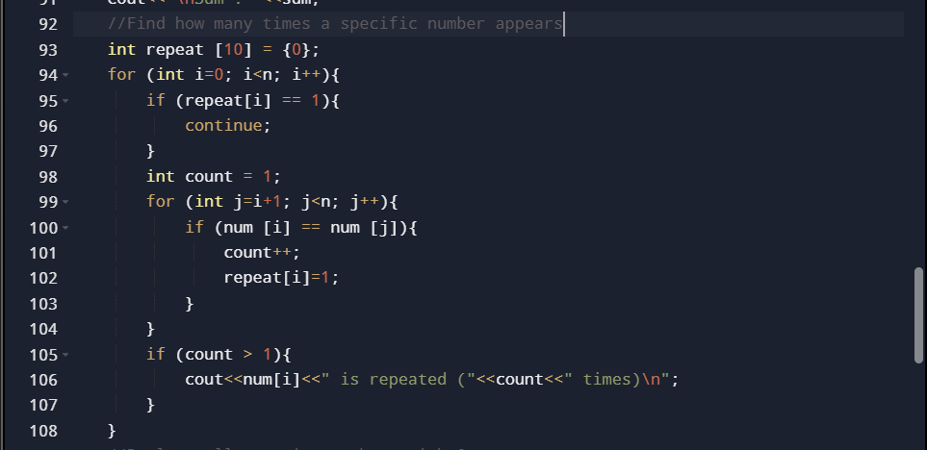

# Replace all negative numbers with 0

# Check if an array is sorted (ascending)

# Shift array elements left or right

# Swap first and last elements

